**PART 2: DESIGN ALTERNATIVES**

**SCENARIOS:**

**Scenario 1 –** Mark, a freshman who recently transferred to the big city has had trouble in finding locations where the cheapest meals are nearby. He got food from known fast food chains which costs him a lot whenever he eats.

**Scenario -** Dick, a food vlogger from the US wants to go around the city and eat food but available information about the places is lacking. This caused him to just play it safe and get into tourist traps which charged him lots of money.

**Scenario 3 –** Willy plans when buying food In advance, however, the price reference on food apps and actual prices have significant markups that he cannot plan accurately. This results in him carrying excess money when buying out which only inconveniences him.

**Storyboard (Based on Scenarios):**

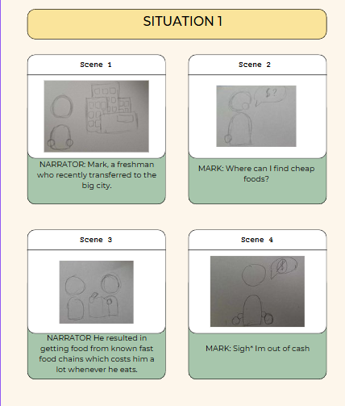

**Storyboard 1 – Mark**

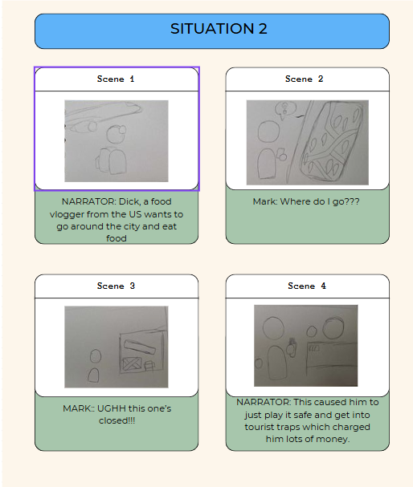

**Storyboard 2 – Dick**

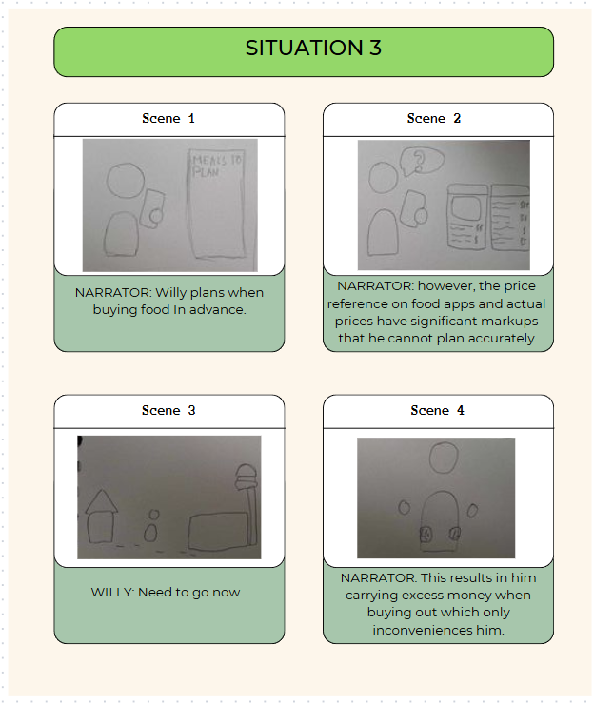

**Scenario 3 – Willy**

**Problem Statement:**

**-**Lack of relevant Information on viable food places.

**-**Lack of updated information to ascertain human consciousness.

**-**Lack of accurate information relevant to food prices.

**Application Icon Size Comparison**

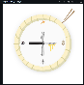

36X36 48X48 72X72 96X96 144x144 192x192

The icons presented above showcase the application icon in various sizes. This is essential in identifying the looks of the icon in various resolutions and ratios.

**Design Space**

***Design Requirements***

When designing, considerations were made as to how the application would function. Basic functionalities such as maps, menus, and establishments must be considered as vital as the application is based on users interacting with the given data. However, as the developers add more variables to the mix, having to design a UI and feature to work around various variables becomes much more complicated which makes the implementation much harder, thus the application ends up with fewer variables to consider compared to the initial plans.

***Design Limitations***

When designing the application features, there were several considerations to be made as to what feature to include in the final prototype. Prioritizations on what data should be emphasized to prevent increasing the device requirements and bloating the system. The Application made a compromise of presenting both map and item but at the expense of complexity which ended up being a basic application to display food locations, menus, and plans.

***Design Support***

The easiest part of the application to support is by implementing additional data to the menu. As it is a basic application in its prototype stages, additional information about the establishment, accuracy of menu data, and prices can be quickly implemented and new data can be inserted as needed.

**Design Difficulties**

The design implementation will require studies on existing GUI applications as well as device specifications to be able to create a usable framework while also making sure that every device functions and conforms to the UI design.

**Design**

The CraveCompas application aims to showcase modern design in a utilitarian aspect. The design is inspired by various existing applications and templates for easier familiarization with it**.**

**Color Palettes**







The application Uses various vibrant colors which are based around logo companies. Yellow is the main color with white as the backdrop. Other colors are associated with brand logos to also add varieties to the application

**Font Style**

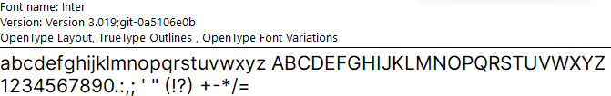

The application uses the font Inter as its font. This is to provide a more readable formal font applicable to a general-use application. This font is used in computer interfaces, displays, and programs that present information due to its design specially crafted for screen displays.

**GUI**

The GUI used for the interface of the application is in iPhone 13 & 14, which has a dimension of 390 x 844. To aid users in efficiently navigating the app, this prototype has elements like a clear visual hierarchy, easy-to-read typography, and a basic and clean layout.

**Sample Features Flows**

**Design Sketches and Alternatives**

The design sketch for the prototype includes a welcome screen, which displays the logo of the Crave Compass app and a slogan, followed by the home screen that provides a similar look with the other food applications, which makes the user feel that he/she already knows how to navigate the app. The home screen has various elements such as images, icons, search bar, food map, and the navigation bar, which navigates you to various parts of the application. Some of the sketches here might not be in the final version of the prototype but most of it are already decided to be included in the prototype.

**Full Sketch**

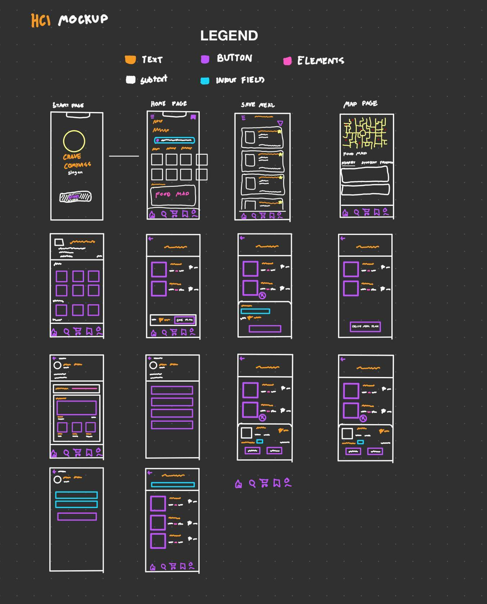

**Legend**

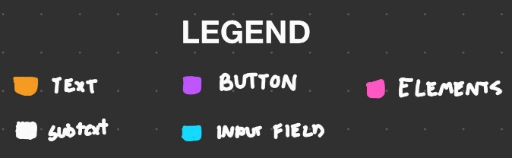

This is the legend for all the colors used in the sketch. Orange is for the main/bigger text, white for the sub text, violet for the elements that can be interacted with, pink for the additional elements (stars, image icons, graphics), and turquoise for the input fields.

**Welcome Screen**

|  |  |
| --- | --- |
|  | The welcome screen of the application features the Crave Compass logo with a slogan “Cravings satisfied. Direction delivered” below it. It also has a button “Start” which takes you to the next page. |

**Home Screen**

|  |  |
| --- | --- |
|  | In the home screen you can see various elements which can lead you to different pages. At the bottom you can see the navigation bar, at the top the saves page with the bookmark icon, and below that is the search bar. You can also scroll the boxes horizontally which represents the meals. Below that you can see the Food Map, which takes you to a different page dedicated for it. |

**Search Meal Page**

|  |  |
| --- | --- |
|  | In this page you can search meals that you are craving for. You can also see details of the meal that you are searching for like their price, estimated delivery time, and their distance from your location. |

**Food Map**

|  |  |
| --- | --- |
|  | Here comes the Food Map Page which is an innovative feature on our part that we haven’t seen on other food apps. In this page you can open the map and can view food stores that are available in your area. You can filter out food stores based on your preferred options, view nearby, student-friendly, budget, popular, etc. |

**Saves Page**

|  |  |
| --- | --- |
|  | In this page, you can see all of the cravings that you’ve saved, which is helpful in the future when you want your cravings to be satisfied. |

**Food Store Page**

|  |  |
| --- | --- |
|  | The Food Store page lets you explore a specific food shop page. You can see their menu, their categories, and details of their meals that they offer. |

**Save Meal List Page**

|  |  |
| --- | --- |
|  | In this page, you can create your own meal plan, which consists of anything you like grouped into one.  After that, you save it and proceed to the next page where you can do some customizations. |

**Custom Meal Plan Page**

|  |  |
| --- | --- |
|  | The custom meal plan page lets you customize your meal plan, which you can edit the quantity, and delete a a single meal. |

**Account Page**

|  |  |
| --- | --- |
|  | The Account page shows your details and your recent cravings. Your contributions are also displayed in this page where you recommended a specific meal and then several people commended your craving recommendation.  In the second page, you can see the settings and some buttons that can let you view contributions, your license, statistics, delete data, and meet the founders of the app.  In the third page, you can edit your account info. |

**Mock-up/Prototype**

|  |  |
| --- | --- |
|  |  |

|  |  |  |
| --- | --- | --- |
| **Splash screen**  Contains the logo and a get started button for the users to start. |   **Menu Screen**  Contains most of the functionalities including navigation buttons, item previews, food maps, and popular brands. |   **Search Menu**  Contains a search field to enter desired food to view. |
| **Food Map**  Contains locations of nearest food locations and establishments. |   **Establishment view**  Contains food available in selected establishments included with prices. |   **Meal Plan Checkout**  Selected meals that can be stored as custom meals to be used as references. |
|   **Saved Meal Plans** This contains the saved meal plans which can be viewed as references |   **Account Menu**  This contains the local account which contains recent activities. |   **Food Menu**  This contains manipulation when adding food to the meal plan. |
|   **Saved Meals**  Displays saved meals added by user |   **Custom Meal Menu**  Displays the saved custom meal plan |   **Item Edit Menu**  Displays options for item. |
|   **Edit Account Info**  Edit username and description (local) |   **Account info**  Contains account and app manipulation (Only edit account info works) |  |